Logic Design

EECS101001

Lab 3: Pattern Detector – Report

104021215 熊 磊

1. Foreword

This Lab is trying to design a Pattern Detector. When we detect the following pattern, the machine should set the flag to 1.

**110(010)+10**

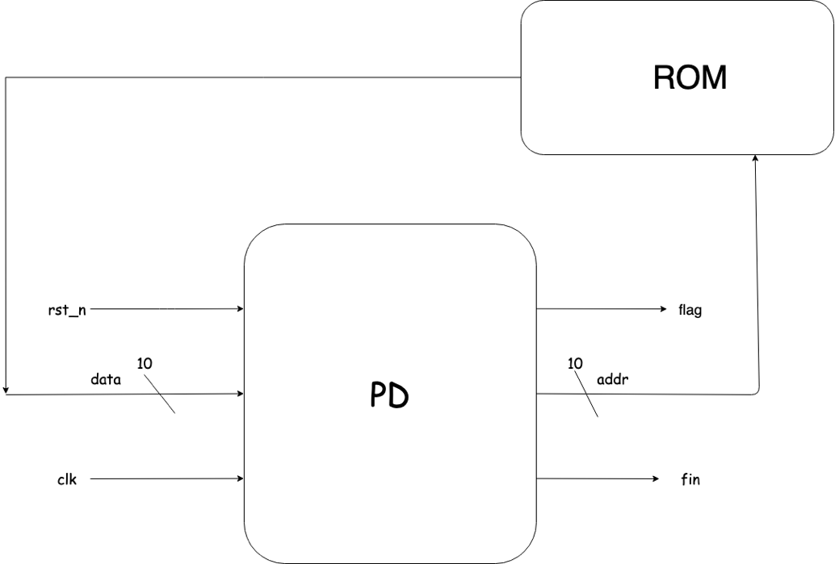

### Input

|  |  |  |
| --- | --- | --- |
| **name** | **width** | **function** |
| clk | 1-bit | clock signal |
| rst_n | 1-bit | 當rst_n = 0的時候，reset detector並從下個cycle 開始進行運算 |
| data | 10-bit | 從ROM讀出來的訊號，我們的bit pattern會放在 data[0] |

### Output

|  |  |  |
| --- | --- | --- |
| **name** | **width** | **function** |
| flag | 1-bit | 當我們讀取到一個pattern的尾端的cycle拉成1 |
| addr | 10-bit | 控制我們要從ROM裡面的哪個位置讀取值，有效資料的長度會放在 addr = 1023 |
| fin | 1-bit | 當運算結束（偵測完有效資料之後）設成 1 |

1. Implementation Details and Designs

Pattern Detector

First, we draw a State Transition Graph as Follow:

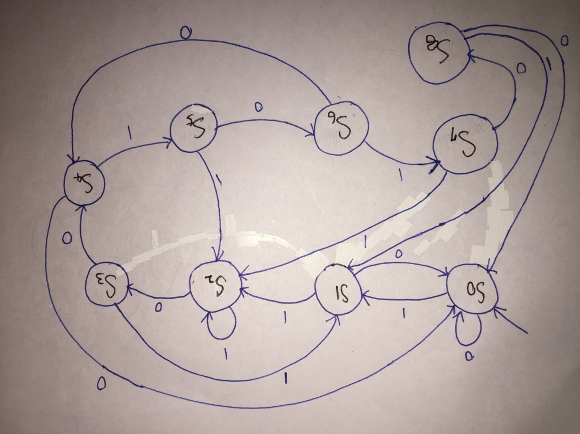

We need at least 9 States to detect the pattern, hence we must define states with at least 4 bits. And we use another two states, INIT and FINI, for initial and finish state.



Since, we have to design an independent DFF outside the PD module, we design a more powerful DFF, with **rst_n** and **init_out**.

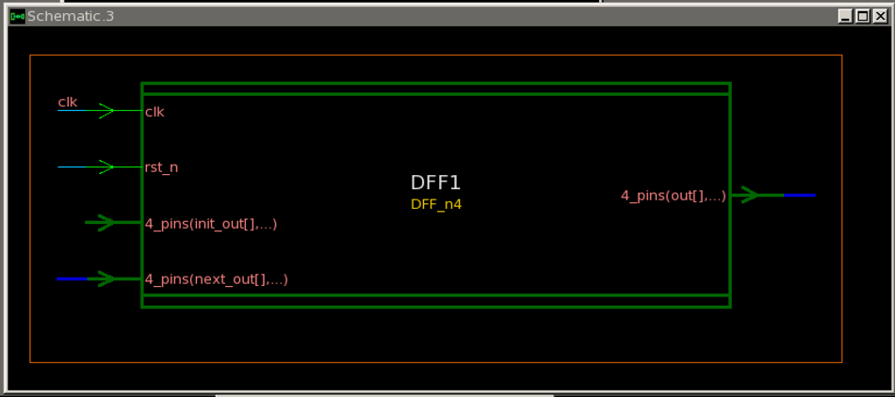

The code is design like this:



**out** will be assign to **init_out** when **rst_n** is 0, otherwise is **next_out**. We have to use DFF to remember the state. Another reason that why using DFF to set up value is DFF is more stable for hardware description language.

***Observation:*** *If I assign value without using DFF, e.g.* **counter***, the value will be wrong value.*

The remain part is the PD module; we introduce the design choice first. Since we can’t assign value in **always** block, they need to be declared as wire.





We take a small part of **always** block for explanation; remaining part is similar. As the State Transition Graph, we drew above; **next_state** of Initial state is **S0**. **flag** will only be assigned to 1 in a moment when state **S7** transiting to **S8**.

Luxury Pattern Detector

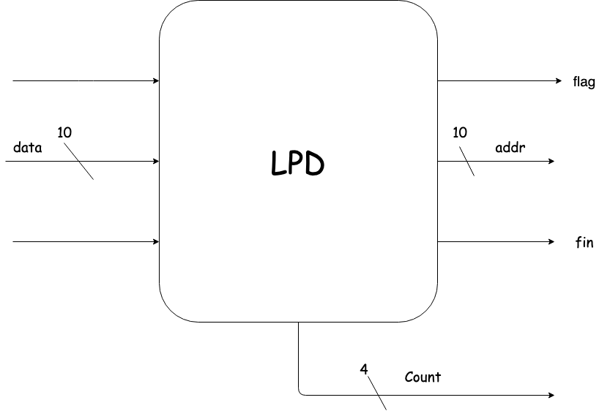

Since for Luxury Pattern Detector, we need to detect one more pattern **(111)**, it takes three more states. It can, however, be extend from **S2** we designed before in PD.

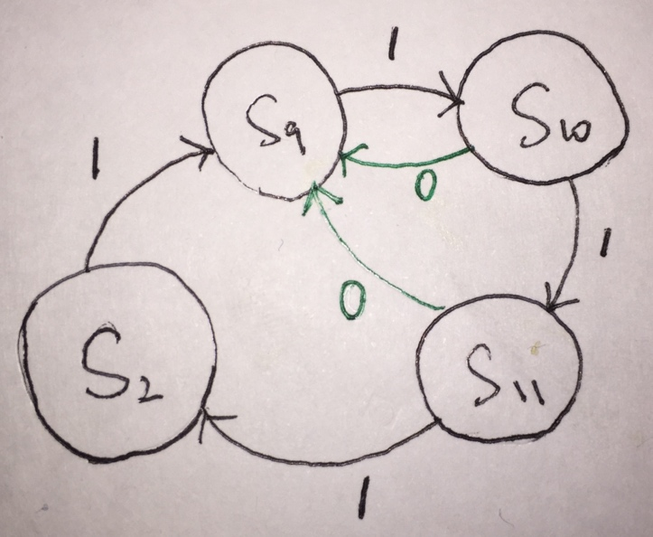 

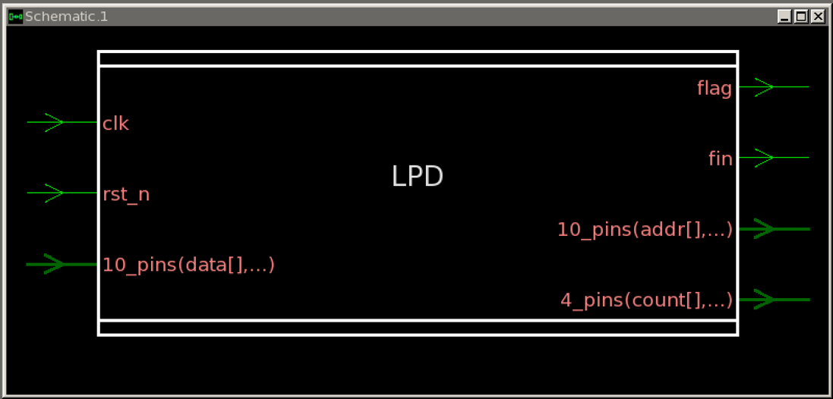

On the other hand, as we need to count how many **(010)** has been detected and stop counting when we detect the pattern **(111)**.

We set the increment of **counter** at state **S6**.



It is very clear after we drew the State Transition Graph above. The point that worth to be emphasize is that we should set count to total number of patterns at the end of the valid digits.



1. nWave Result

Pattern Detector

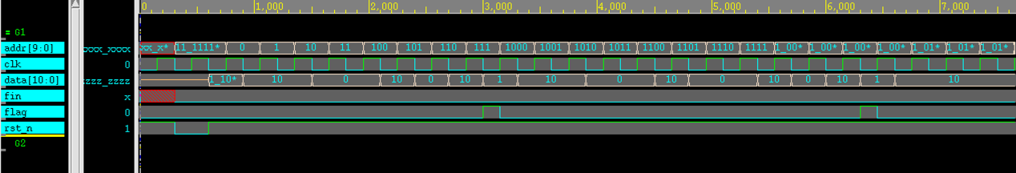

Luxury Pattern Detector

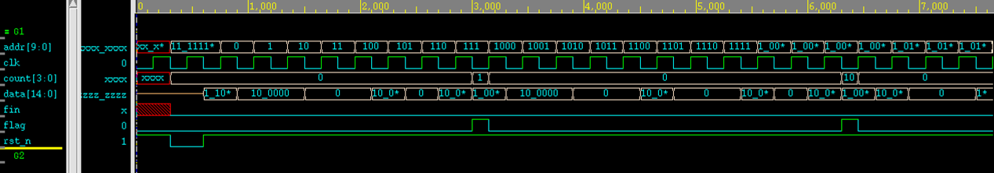

1. Report Area

Pattern Detector Luxury Pattern Detector

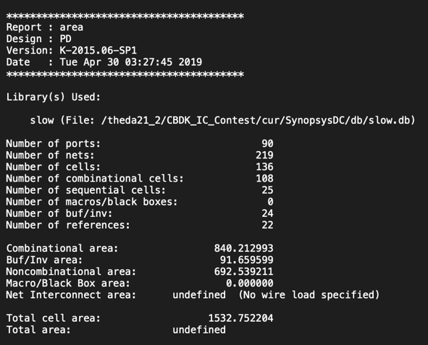 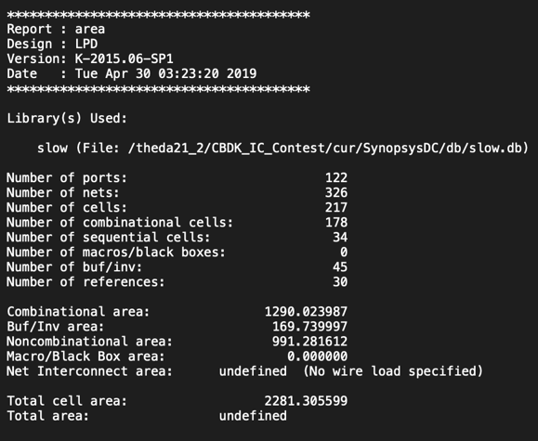

1. Encountered Problems and Solving

* We can assign address with DFF.
* If I assign value without using DFF, e.g. **counter**, the value will be wrong value.

1. Questions

* Why I have to use **negedge** here, since I will get error if I set **posedge**?

1. Impression and Experience

This time is trying to use DFF to design a so-called Finite State Machine. DFF is really special, and also amazing module for me. Since it can help machine to remember and also make it more stable!